WEEK_2
PL/SQL Control Structures & Stored Procedures

Exercise 1: Control Structures

Scenario 1: The bank wants to apply a discount to loan interest rates for customers above 60 years old.
  - Question: Write a PL/SQL block that loops through all customers, checks their age, and if they are above 60, apply a 1% discount to their current loan interest rates.
Program: CREATE TABLE CUSTOMERS (
CUSTOMER_ID NUMBER PRIMARY KEY,
AGE NUMBER,
LOAN_INTEREST NUMBER
);
SELECT table_name FROM user_tables WHERE table_name = 'CUSTOMERS';
DESC CUSTOMERS;
DROP TABLE CUSTOMERS;
CREATE TABLE CUSTOMERS (
CUSTOMER_ID NUMBER PRIMARY KEY,
AGE NUMBER,
LOAN_INTEREST NUMBER
);
INSERT INTO CUSTOMERS VALUES (1, 65, 9.5);
INSERT INTO CUSTOMERS VALUES (2, 45, 10.0);
INSERT INTO CUSTOMERS VALUES (3, 70, 8.0);
INSERT INTO CUSTOMERS VALUES (4, 61, 7.5);
COMMIT;
SET SERVEROUTPUT ON;

DECLARE
CURSOR cust_cursor IS
SELECT CUSTOMER_ID, AGE, LOAN_INTEREST FROM CUSTOMERS;
BEGIN
FOR cust_rec IN cust_cursor LOOP
IF cust_rec.AGE > 60 THEN
UPDATE CUSTOMERS
SET LOAN_INTEREST = cust_rec.LOAN_INTEREST - 1
WHERE CUSTOMER_ID = cust_rec.CUSTOMER_ID;

DBMS_OUTPUT.PUT_LINE('1% discount applied to customer ID: ' || cust_rec.CUSTOMER_ID);
END IF;
END LOOP;

COMMIT;
END;
/

OUTPUT:

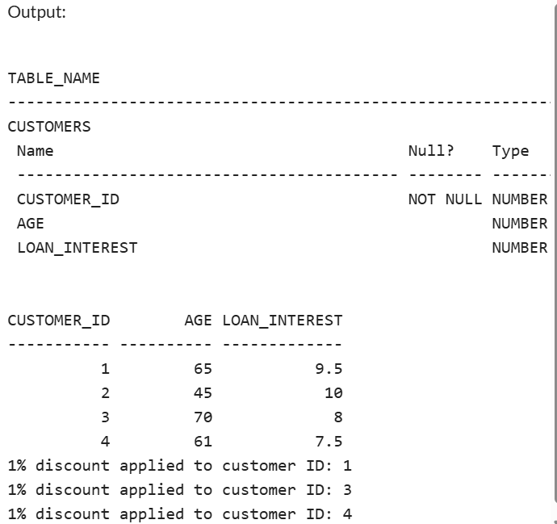

Scenario 2: A customer can be promoted to VIP status based on their balance.
  - Question: Write a PL/SQL block that iterates through all customers and sets a flag IsVIP to TRUE for those with a balance over $10,000.
Program:
CREATE TABLE CUSTOMERS (
CUSTOMER_ID NUMBER PRIMARY KEY,
BALANCE NUMBER(10, 2),
ISVIP VARCHAR2(5) DEFAULT 'FALSE'
);
INSERT INTO CUSTOMERS (CUSTOMER_ID, BALANCE) VALUES (1, 9500);
INSERT INTO CUSTOMERS (CUSTOMER_ID, BALANCE) VALUES (2, 15000);
INSERT INTO CUSTOMERS (CUSTOMER_ID, BALANCE) VALUES (3, 3000);
INSERT INTO CUSTOMERS (CUSTOMER_ID, BALANCE) VALUES (4, 25000);
INSERT INTO CUSTOMERS (CUSTOMER_ID, BALANCE) VALUES (5, 10500);
COMMIT;
SET SERVEROUTPUT ON;

BEGIN
FOR cust IN (SELECT CUSTOMER_ID, BALANCE FROM CUSTOMERS) LOOP
IF cust.BALANCE > 10000 THEN
UPDATE CUSTOMERS
SET ISVIP = 'TRUE'
WHERE CUSTOMER_ID = cust.CUSTOMER_ID;
ELSE
UPDATE CUSTOMERS
SET ISVIP = 'FALSE'
WHERE CUSTOMER_ID = cust.CUSTOMER_ID;
END IF;
END LOOP;

COMMIT;
DBMS_OUTPUT.PUT_LINE('VIP flags updated successfully.');
END;
/
SELECT CUSTOMER_ID, BALANCE, ISVIP FROM CUSTOMERS;
OUTPUT:
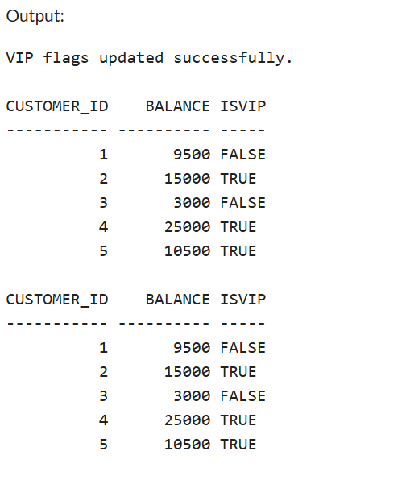

Scenario 3: The bank wants to send reminders to customers whose loans are due within the next 30 days.
  - Question: Write a PL/SQL block that fetches all loans due in the next 30 days and prints a reminder message for each customer.

Program:
SET SERVEROUTPUT ON;
SET DEFINE OFF;

-- Create the table
CREATE TABLE LOANS (
LOAN_ID NUMBER PRIMARY KEY,
CUSTOMER_ID NUMBER,
DUE_DATE DATE,
AMOUNT NUMBER(10, 2)
);

-- Insert sample data
INSERT INTO LOANS VALUES (1, 101, TO_DATE('2025-07-10', 'YYYY-MM-DD'), 5000);
INSERT INTO LOANS VALUES (2, 102, TO_DATE('2025-08-15', 'YYYY-MM-DD'), 7000);
INSERT INTO LOANS VALUES (3, 103, TO_DATE('2025-07-05', 'YYYY-MM-DD'), 8000);
INSERT INTO LOANS VALUES (4, 104, TO_DATE('2025-06-20', 'YYYY-MM-DD'), 6000);
COMMIT;
SELECT * FROM LOANS;

-- PL/SQL block to send reminders
BEGIN
FOR loan_rec IN (
SELECT LOAN_ID, CUSTOMER_ID, DUE_DATE, AMOUNT
FROM LOANS
WHERE DUE_DATE BETWEEN SYSDATE AND SYSDATE + 30
) LOOP
DBMS_OUTPUT.PUT_LINE(
'Reminder: Customer ' || loan_rec.CUSTOMER_ID ||
', your loan ID ' || loan_rec.LOAN_ID ||
' of amount $' || loan_rec.AMOUNT ||
' is due on ' || TO_CHAR(loan_rec.DUE_DATE, 'DD-Mon-YYYY')
);
END LOOP;
END;
/
OUTPUT:
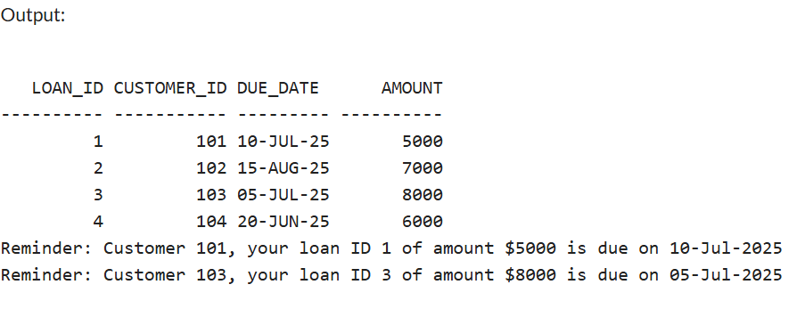

Exercise 3: Stored Procedures

Scenario 1: The bank needs to process monthly interest for all savings accounts.
  - Question: Write a stored procedure ProcessMonthlyInterest that calculates and updates the balance of all savings accounts by applying an interest rate of 1% to the current balance.
PROGRAM:
-- Drop tables first if re-running
BEGIN
EXECUTE IMMEDIATE 'DROP TABLE Transactions';
EXECUTE IMMEDIATE 'DROP TABLE Accounts';
EXECUTE IMMEDIATE 'DROP TABLE Loans';
EXECUTE IMMEDIATE 'DROP TABLE Employees';
EXECUTE IMMEDIATE 'DROP TABLE Customers';
EXCEPTION
WHEN OTHERS THEN NULL;
END;
/

-- Customers table
CREATE TABLE Customers (
CustomerID NUMBER PRIMARY KEY,
Name VARCHAR2(100),
DOB DATE,
Balance NUMBER,
LastModified DATE
);

-- Accounts table
CREATE TABLE Accounts (
AccountID NUMBER PRIMARY KEY,
CustomerID NUMBER,
AccountType VARCHAR2(20),
Balance NUMBER,
LastModified DATE,
FOREIGN KEY (CustomerID) REFERENCES Customers(CustomerID)
);

-- Transactions table
CREATE TABLE Transactions (
TransactionID NUMBER PRIMARY KEY,
AccountID NUMBER,
TransactionDate DATE,
Amount NUMBER,
TransactionType VARCHAR2(10),
FOREIGN KEY (AccountID) REFERENCES Accounts(AccountID)
);

-- Loans table
CREATE TABLE Loans (
LoanID NUMBER PRIMARY KEY,
CustomerID NUMBER,
LoanAmount NUMBER,
InterestRate NUMBER,
StartDate DATE,
EndDate DATE,
FOREIGN KEY (CustomerID) REFERENCES Customers(CustomerID)
);

-- Employees table
CREATE TABLE Employees (
EmployeeID NUMBER PRIMARY KEY,
Name VARCHAR2(100),
Position VARCHAR2(50),
Salary NUMBER,
Department VARCHAR2(50),
HireDate DATE
);

-- Sample Data Insertion
-- Customers
INSERT INTO Customers VALUES (1, 'John Doe', TO_DATE('1985-05-15', 'YYYY-MM-DD'), 1000, SYSDATE);
INSERT INTO Customers VALUES (2, 'Jane Smith', TO_DATE('1990-07-20', 'YYYY-MM-DD'), 1500, SYSDATE);

-- Accounts
INSERT INTO Accounts VALUES (1, 1, 'Savings', 1000, SYSDATE);
INSERT INTO Accounts VALUES (2, 2, 'Checking', 1500, SYSDATE);

-- Transactions
INSERT INTO Transactions VALUES (1, 1, SYSDATE, 200, 'Deposit');
INSERT INTO Transactions VALUES (2, 2, SYSDATE, 300, 'Withdrawal');

-- Loans
INSERT INTO Loans VALUES (1, 1, 5000, 5, SYSDATE, ADD_MONTHS(SYSDATE, 60));

-- Employees
INSERT INTO Employees VALUES (1, 'Alice Johnson', 'Manager', 70000, 'HR', TO_DATE('2015-06-15', 'YYYY-MM-DD'));
INSERT INTO Employees VALUES (2, 'Bob Brown', 'Developer', 60000, 'IT', TO_DATE('2017-03-20', 'YYYY-MM-DD'));

COMMIT;

-- Procedure: ProcessMonthlyInterest
CREATE OR REPLACE PROCEDURE ProcessMonthlyInterest
IS
BEGIN
UPDATE Accounts
SET Balance = Balance + (Balance * 0.01),
LastModified = SYSDATE
WHERE AccountType = 'Savings';

COMMIT;
DBMS_OUTPUT.PUT_LINE('Monthly interest applied to all savings accounts.');
END;
/

-- Enable DBMS output
SET SERVEROUTPUT ON;

-- Execute the procedure
EXEC ProcessMonthlyInterest;

-- Check updated balances
SELECT * FROM Accounts;

OUTPUT:
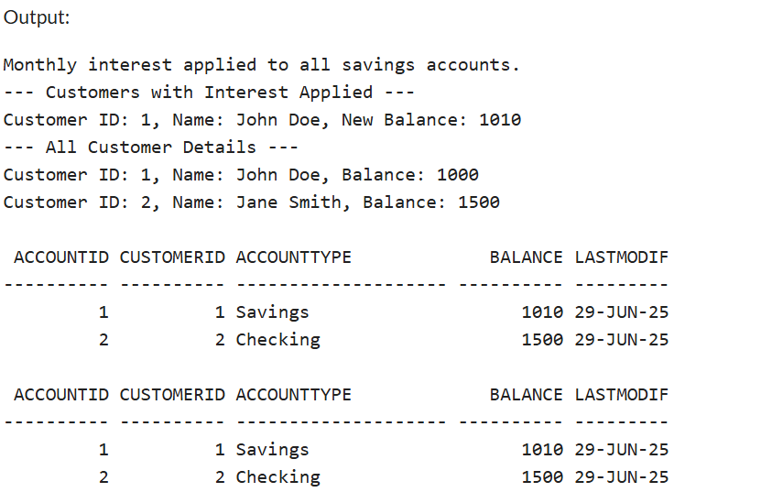

Scenario 2: The bank wants to implement a bonus scheme for employees based on their performance.
  - Question: Write a stored procedure UpdateEmployeeBonus that updates the salary of employees in a given department by adding a bonus percentage passed as a parameter.
PROGRAM:
-- Drop tables first if re-running
BEGIN
EXECUTE IMMEDIATE 'DROP TABLE Transactions';
EXECUTE IMMEDIATE 'DROP TABLE Accounts';
EXECUTE IMMEDIATE 'DROP TABLE Loans';
EXECUTE IMMEDIATE 'DROP TABLE Employees';
EXECUTE IMMEDIATE 'DROP TABLE Customers';
EXCEPTION
WHEN OTHERS THEN NULL;
END;
/

-- Customers table
CREATE TABLE Customers (
CustomerID NUMBER PRIMARY KEY,
Name VARCHAR2(100),
DOB DATE,
Balance NUMBER,
LastModified DATE
);

-- Accounts table
CREATE TABLE Accounts (
AccountID NUMBER PRIMARY KEY,
CustomerID NUMBER,
AccountType VARCHAR2(20),
Balance NUMBER,
LastModified DATE,
FOREIGN KEY (CustomerID) REFERENCES Customers(CustomerID)
);

-- Transactions table
CREATE TABLE Transactions (
TransactionID NUMBER PRIMARY KEY,
AccountID NUMBER,
TransactionDate DATE,
Amount NUMBER,
TransactionType VARCHAR2(10),
FOREIGN KEY (AccountID) REFERENCES Accounts(AccountID)
);

-- Loans table
CREATE TABLE Loans (
LoanID NUMBER PRIMARY KEY,
CustomerID NUMBER,
LoanAmount NUMBER,
InterestRate NUMBER,
StartDate DATE,
EndDate DATE,
FOREIGN KEY (CustomerID) REFERENCES Customers(CustomerID)
);

-- Employees table
CREATE TABLE Employees (
EmployeeID NUMBER PRIMARY KEY,
Name VARCHAR2(100),
Position VARCHAR2(50),
Salary NUMBER,
Department VARCHAR2(50),
HireDate DATE
);

-- Sample Data Insertion
-- Customers
INSERT INTO Customers VALUES (1, 'John Doe', TO_DATE('1985-05-15', 'YYYY-MM-DD'), 1000, SYSDATE);
INSERT INTO Customers VALUES (2, 'Jane Smith', TO_DATE('1990-07-20', 'YYYY-MM-DD'), 1500, SYSDATE);

-- Accounts
INSERT INTO Accounts VALUES (1, 1, 'Savings', 1000, SYSDATE);
INSERT INTO Accounts VALUES (2, 2, 'Checking', 1500, SYSDATE);

-- Transactions
INSERT INTO Transactions VALUES (1, 1, SYSDATE, 200, 'Deposit');
INSERT INTO Transactions VALUES (2, 2, SYSDATE, 300, 'Withdrawal');

-- Loans
INSERT INTO Loans VALUES (1, 1, 5000, 5, SYSDATE, ADD_MONTHS(SYSDATE, 60));

-- Employees
INSERT INTO Employees VALUES (1, 'Alice Johnson', 'Manager', 70000, 'HR', TO_DATE('2015-06-15', 'YYYY-MM-DD'));
INSERT INTO Employees VALUES (2, 'Bob Brown', 'Developer', 60000, 'IT', TO_DATE('2017-03-20', 'YYYY-MM-DD'));

COMMIT;

-- Procedure: ProcessMonthlyInterest
CREATE OR REPLACE PROCEDURE ProcessMonthlyInterest
IS
BEGIN
UPDATE Accounts
SET Balance = Balance + (Balance * 0.01),
LastModified = SYSDATE
WHERE AccountType = 'Savings';

COMMIT;
DBMS_OUTPUT.PUT_LINE('Monthly interest applied to all savings accounts.');

DBMS_OUTPUT.PUT_LINE('--- Customers with Interest Applied ---');
FOR rec IN (
SELECT c.CustomerID, c.Name, a.Balance
FROM Customers c
JOIN Accounts a ON c.CustomerID = a.CustomerID
WHERE a.AccountType = 'Savings'
) LOOP
DBMS_OUTPUT.PUT_LINE('Customer ID: ' || rec.CustomerID || ', Name: ' || rec.Name || ', New Balance: ' || rec.Balance);
END LOOP;

DBMS_OUTPUT.PUT_LINE('--- All Customer Details ---');
FOR cust IN (
SELECT * FROM Customers
) LOOP
DBMS_OUTPUT.PUT_LINE('Customer ID: ' || cust.CustomerID || ', Name: ' || cust.Name || ', Balance: ' || cust.Balance);
END LOOP;
END;
/

-- Procedure: UpdateEmployeeBonus
CREATE OR REPLACE PROCEDURE UpdateEmployeeBonus (
p_department IN VARCHAR2,
p_bonus_percent IN NUMBER
)
IS
BEGIN
UPDATE Employees
SET Salary = Salary + (Salary * p_bonus_percent / 100)
WHERE Department = p_department;

COMMIT;
DBMS_OUTPUT.PUT_LINE('Bonus of ' || p_bonus_percent || '% applied to employees in department: ' || p_department);

DBMS_OUTPUT.PUT_LINE('--- Updated Employee Details ---');
FOR emp IN (
SELECT * FROM Employees WHERE Department = p_department
) LOOP
DBMS_OUTPUT.PUT_LINE('Employee ID: ' || emp.EmployeeID || ', Name: ' || emp.Name || ', New Salary: ' || emp.Salary);
END LOOP;
END;
/

-- Enable DBMS output
SET SERVEROUTPUT ON;

-- Execute the procedures
EXEC ProcessMonthlyInterest;
EXEC UpdateEmployeeBonus('IT', 10);

-- Check updated balances and salaries
SELECT * FROM Accounts;
SELECT * FROM Employees;
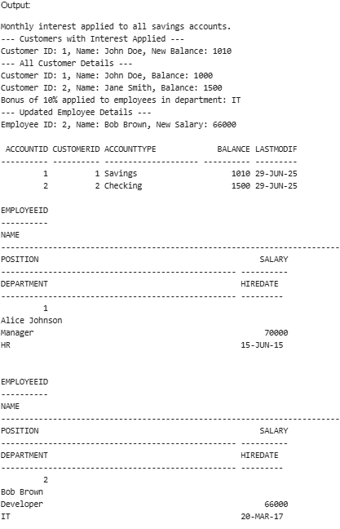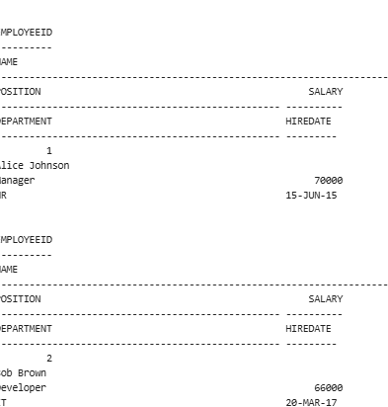

Scenario 3: Customers should be able to transfer funds between their accounts.
  - Question: Write a stored procedure TransferFunds that transfers a specified amount from one account to another, checking that the source account has sufficient balance before making the transfer.
PRogram:
-- Drop tables first if re-running
BEGIN
EXECUTE IMMEDIATE 'DROP TABLE Transactions';
EXECUTE IMMEDIATE 'DROP TABLE Accounts';
EXECUTE IMMEDIATE 'DROP TABLE Loans';
EXECUTE IMMEDIATE 'DROP TABLE Employees';
EXECUTE IMMEDIATE 'DROP TABLE Customers';
EXCEPTION
WHEN OTHERS THEN NULL;
END;
/

-- Customers table
CREATE TABLE Customers (
CustomerID NUMBER PRIMARY KEY,
Name VARCHAR2(100),
DOB DATE,
Balance NUMBER,
LastModified DATE
);

-- Accounts table
CREATE TABLE Accounts (
AccountID NUMBER PRIMARY KEY,
CustomerID NUMBER,
AccountType VARCHAR2(20),
Balance NUMBER,
LastModified DATE,
FOREIGN KEY (CustomerID) REFERENCES Customers(CustomerID)
);

-- Transactions table
CREATE TABLE Transactions (
TransactionID NUMBER PRIMARY KEY,
AccountID NUMBER,
TransactionDate DATE,
Amount NUMBER,
TransactionType VARCHAR2(10),
FOREIGN KEY (AccountID) REFERENCES Accounts(AccountID)
);

-- Loans table
CREATE TABLE Loans (
LoanID NUMBER PRIMARY KEY,
CustomerID NUMBER,
LoanAmount NUMBER,
InterestRate NUMBER,
StartDate DATE,
EndDate DATE,
FOREIGN KEY (CustomerID) REFERENCES Customers(CustomerID)
);

-- Employees table
CREATE TABLE Employees (
EmployeeID NUMBER PRIMARY KEY,
Name VARCHAR2(100),
Position VARCHAR2(50),
Salary NUMBER,
Department VARCHAR2(50),
HireDate DATE
);

-- Sample Data Insertion
-- Customers
INSERT INTO Customers VALUES (1, 'John Doe', TO_DATE('1985-05-15', 'YYYY-MM-DD'), 1000, SYSDATE);
INSERT INTO Customers VALUES (2, 'Jane Smith', TO_DATE('1990-07-20', 'YYYY-MM-DD'), 1500, SYSDATE);

-- Accounts
INSERT INTO Accounts VALUES (1, 1, 'Savings', 1000, SYSDATE);
INSERT INTO Accounts VALUES (2, 2, 'Checking', 1500, SYSDATE);

-- Transactions
INSERT INTO Transactions VALUES (1, 1, SYSDATE, 200, 'Deposit');
INSERT INTO Transactions VALUES (2, 2, SYSDATE, 300, 'Withdrawal');

-- Loans
INSERT INTO Loans VALUES (1, 1, 5000, 5, SYSDATE, ADD_MONTHS(SYSDATE, 60));

-- Employees
INSERT INTO Employees VALUES (1, 'Alice Johnson', 'Manager', 70000, 'HR', TO_DATE('2015-06-15', 'YYYY-MM-DD'));
INSERT INTO Employees VALUES (2, 'Bob Brown', 'Developer', 60000, 'IT', TO_DATE('2017-03-20', 'YYYY-MM-DD'));

COMMIT;

-- Procedure: ProcessMonthlyInterest
CREATE OR REPLACE PROCEDURE ProcessMonthlyInterest
IS
BEGIN
UPDATE Accounts
SET Balance = Balance + (Balance * 0.01),
LastModified = SYSDATE
WHERE AccountType = 'Savings';

COMMIT;
DBMS_OUTPUT.PUT_LINE('Monthly interest applied to all savings accounts.');

DBMS_OUTPUT.PUT_LINE('--- Customers with Interest Applied ---');
FOR rec IN (
SELECT c.CustomerID, c.Name, a.Balance
FROM Customers c
JOIN Accounts a ON c.CustomerID = a.CustomerID
WHERE a.AccountType = 'Savings'
) LOOP
DBMS_OUTPUT.PUT_LINE('Customer ID: ' || rec.CustomerID || ', Name: ' || rec.Name || ', New Balance: ' || rec.Balance);
END LOOP;

DBMS_OUTPUT.PUT_LINE('--- All Customer Details ---');
FOR cust IN (
SELECT * FROM Customers
) LOOP
DBMS_OUTPUT.PUT_LINE('Customer ID: ' || cust.CustomerID || ', Name: ' || cust.Name || ', Balance: ' || cust.Balance);
END LOOP;
END;
/

-- Procedure: UpdateEmployeeBonus
CREATE OR REPLACE PROCEDURE UpdateEmployeeBonus (
p_department IN VARCHAR2,
p_bonus_percent IN NUMBER
)
IS
BEGIN
UPDATE Employees
SET Salary = Salary + (Salary * p_bonus_percent / 100)
WHERE Department = p_department;

COMMIT;
DBMS_OUTPUT.PUT_LINE('Bonus of ' || p_bonus_percent || '% applied to employees in department: ' || p_department);

DBMS_OUTPUT.PUT_LINE('--- Updated Employee Details ---');
FOR emp IN (
SELECT * FROM Employees WHERE Department = p_department
) LOOP
DBMS_OUTPUT.PUT_LINE('Employee ID: ' || emp.EmployeeID || ', Name: ' || emp.Name || ', New Salary: ' || emp.Salary);
END LOOP;
END;
/

-- Procedure: TransferFunds
CREATE OR REPLACE PROCEDURE TransferFunds (
p_from_account IN NUMBER,
p_to_account IN NUMBER,
p_amount IN NUMBER
)
IS
v_balance NUMBER;
BEGIN
SELECT Balance INTO v_balance FROM Accounts WHERE AccountID = p_from_account FOR UPDATE;

IF v_balance < p_amount THEN
RAISE_APPLICATION_ERROR(-20001, 'Insufficient funds in source account.');
END IF;

UPDATE Accounts
SET Balance = Balance - p_amount,
LastModified = SYSDATE
WHERE AccountID = p_from_account;

UPDATE Accounts
SET Balance = Balance + p_amount,
LastModified = SYSDATE
WHERE AccountID = p_to_account;

INSERT INTO Transactions (TransactionID, AccountID, TransactionDate, Amount, TransactionType)
VALUES (Transactions_seq.NEXTVAL, p_from_account, SYSDATE, p_amount, 'Transfer');

INSERT INTO Transactions (TransactionID, AccountID, TransactionDate, Amount, TransactionType)
VALUES (Transactions_seq.NEXTVAL, p_to_account, SYSDATE, p_amount, 'Receive');

COMMIT;
DBMS_OUTPUT.PUT_LINE('Transferred $' || p_amount || ' from account ' || p_from_account || ' to account ' || p_to_account);
END;
/

-- Enable DBMS output
SET SERVEROUTPUT ON;

-- Execute the procedures
EXEC ProcessMonthlyInterest;
EXEC UpdateEmployeeBonus('IT', 10);
EXEC TransferFunds(1, 2, 200);

-- Check updated balances and salaries
SELECT * FROM Accounts;
SELECT * FROM Employees;
SELECT * FROM Transactions;

OUTPUT
 